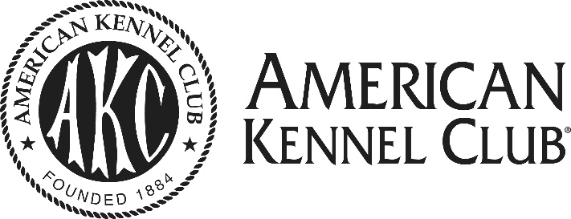
COMMUNITY ACHIEVEMENT AWARD

Nomination Form

A. The nominee is: ____ an individual who is a member of an AKC-recognized club or AKC-affiliated federation

____ an AKC-recognized club

____ an AKC-affiliated federation

Name of nominated individual, club or federation: ______________________________________________________

___________________________________________________________________________________________

If you are nominating an individual, list the club or federation of which he/she is a member: ________________________

___________________________________________________________________________________________

Position held by nominee in his/her club or federation: __________________________________________________

Nominee’s address: ____________________________________________________________________________

___________________________________________________________________________________________

Nominee’s phone: _______________________ E-mail: ________________________________________________

B. Nomination is submitted by: _____________________________________________________________

Position held in club or federation: _________________________________________________________________

Daytime phone: ________________________ E-mail: _________________________________________________

C. Please describe the programs and/or activities you wish to recognize with this nomination.
Please attach separate sheet(s) and be as specific as possible. Include dates, names, audience, number of people reached, media coverage (if applicable), etc.

D. Please include a non-returnable photograph of the nominated individual, club or federation.
Label the photograph(s) with the nominee’s name and club or federation name. Please provide the names and titles of the individuals appearing in the photograph(s). If applicable, include the name and date of the event pictured.

E. Send completed nomination form and checklist items to:
Emily Holmes, Government Relations
American Kennel Club
8051 Arco Corporate Drive, Suite 100
Raleigh, NC
Telephone (919) 816-3549, E-mail emily.holmes@akc.org

CHECKLIST: Only complete nominations will be considered. Have you included the following?

- Photograph of nominated individual, club or federation
- Description of the programs/activities that you wish to be recognized
- Application form with nominee’s and submitter’s name and contact information

